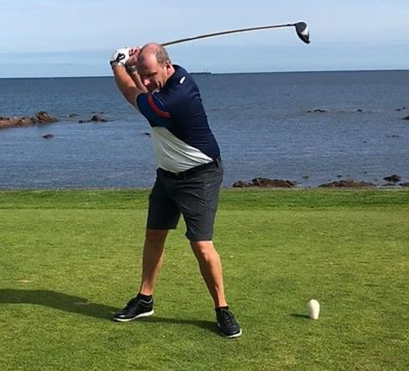

Alan Tait is a PGA “Specialist” Scottish Golf Professional residing in Leith, Edinburgh. As well as being an ex European Tour Player he still actively plays on the Scottish PGA Region Tartan Tour. He is a sought after golf after dinner speaker and has commentated for BBC Radio Scotland at The Open, Scottish Open, Ryder Cup and Solheim Cup. In 2020 he set up the Golfbreaks Get Back to Golf Tour for elite amateurs and professionals. And in 2022 he also founded The Cack Handers Tour for those golfers who hold the club in a unique way!

Alan is also very proud to be an ambassador for Golfbreaks, Glenmuir, Grass Science Seeds, Wilson Golf, B.A.D. Battle Against Dementia, and The Golf Tent. Alan also has a wealth of experience in golf / hospitality management and has worked for leading hotel groups such as Marriott, Macdonalds, Devere and Q-Hotels.

About Alan

FROM THE BEGINNING
Alan Tait first picked up a club at 5 years old. His love for the game was evident from this very early age and it was always his dream to pursue a career from golf. By the time he was 17 he was playing off plus 2 and in 1986 he won The Scottish Boys at Dunbar, before going on to win The Doug Sanders European and World Junior Championships in the same year. During his amateur career he represented Scotland and Great Britain and Ireland and became only the 5th player in Scottish Golf history to be capped at boys, youths and senior levels in the same year. In 1989 he narrowly missed out on winning the National title when he was beaten on the last green by his great friend Alan Thomson in a fantastic 36 hole final at Lossiemouth.

Turning Professional
Alan turned professional in 1990 and enjoyed 4 years at Cawder Golf Club in Glasgow where he completed his PGA training under the watchful eye of former PGA Captain Ken Stevely. In 1996, Alan capped off a brilliant year playing on The PGA Scottish Tartan Tour circuit. He won numerous pro ams as well as the Scottish Assistants Championship and also won the Scottish PGA Matchplay Championship, all of this resulting in him topping the region’s order of merit. He finished the year off by gaining his European Tour Card at San Roque and Sotogrande in Spain, for the 1997 season.
The Carnoustie Connection
He is probably best known for being the first player ever to shoot 64 (8 under par) round the Championship Course at Carnoustie in 1994, at The Daily Express 72 Hole Pro Am Championship.

This record stood for 23 years until none other than Englishman and Ryder Cup star Tommy Fleetwood went one better in The 2017 Dunhill Links.

In light of his course record, the following year back at Carnoustie in The Bells Scottish Open, Alan was asked by the then Masters Champion Ben Crenshaw and a certain Tiger Woods if he would like to join them for a practice round before the tournament!

Alan duly accepted and the experience is certainly one he will never forget.

Beyond
The
Course

Life after the European Tour
Although success was hard to find on the European Tour Alan looks back at his experience with fond memories. He reminisces about the tour in his very popular after dinner routine and his stories about that famous day he played with Ben and Tiger are not to be missed. He enjoys working for BBC Radio Scotland, commentating at events such as The Open, Scottish Open, Ryder and Solheim Cups.

Testimonial
We were delighted to welcome Alan to our annual black tie dinner and he did not disappoint. His ability to deliver golf stories and poke fun at himself at the same time was most refreshing. We were delighted with his contribution to a hugely successful evening.

Alan was definitely the best speaker we have had at the club and we have had many over the years. His real life golf stories were perfect for our audience and was the talk of the club the following day at our winter medal. I am delighted to recommend Alan for any golf event

